Exercise 2: E-commerce Platform Search Function
Understanding Asymptotic Notation:
Big O notation describes how an algorithm's runtime or space requirements grow as the input size grows. It provides an upper bound on complexity:
- O(1) : Constant time (best case)
- O(long n) : Logarithmic time (very efficient)
- O(n) : Linear time
- O(n²) : Quadratic time (less efficient)

Search Operation Scenarios:
- Best-case: The item is found immediately (first element checked)
- Average-case: The item is found after checking half the elements (for linear search)
- Worst-case: The item isn't present or is the last element checked

Implementation:
Product.java
package com.example;
public class Product
{
int productId;
String productName;
String category;

public Product(int productId, String productName, String category)
{
this.productId = productId;
this.productName = productName;
this.category = category;
}
@Override
public String toString() {
return "Product [ID=" + productId + ", Name=" + productName + ", Category=" + category + "]";
}
}

LinearSearch.java
package com.example;
class LinearSearch
{
public static Product search(Product[] products, String name)
{
if (products == null || name == null) return null;
for (Product p : products)
{
if (p != null && name.equalsIgnoreCase(p.getName())) {
return p;
}
}
return null;
}
}

BInarySearch.java

package com.example
class BinarySearch {
public static Product search(Product[] products, int id) {
if (products == null) return null;
int low = 0;
int high = products.length - 1;
while (low <= high) {
int mid = (low + high) >>> 1;
Product midProd = products[mid];
if (midProd == null) return null;
int midId = midProd.getId();
if (midId == id) {
return midProd;
} else if (midId < id) {
low = mid + 1;
} else {
high = mid - 1;
}
}
return null;
}
}

SearchTest.java
import java.util.Arrays;
public class SearchTest
{
public static void main(String[] args)
{
Product[] product = {
new Product(101, "Laptop","Electronics"),
new Product(102, "Shoes","Fashion"),
new Product(103, "Mobile","Electronics"),
new Product(104, "Shirt","Fashion"),
};
System.out.println("Linear Search:");
Product result1 = LinearSearch.search(product, "Mobile");
if (result1 != null)
{
System.out.println("Product found: " + result1);
}
else
{
System.out.println("Product not found.");
}
// sort by id before binary search
Arrays.sort(product, (p1, p2) -> Integer.compare(p1.getId(), p2.getId()));
System.out.println("\n Binary Search:");
Product result2 = BinarySearch.search(product, 102);
if(result2 != null)
{
System.out.println("Product found: "+result2);
}
else
{
System.out.println("Product not found");
}
}
}

Output
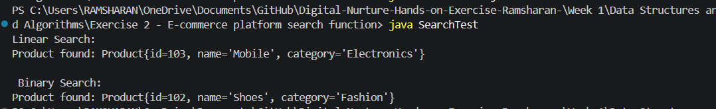

Analysis:

Time Complexity comparison:
Scenario | Linear Search | Binary Search
Best case | O(1) - First element | O(1) - Middle element
Average case | O(n) | O(log n)
Worst case | O(n) | O(log n)

Suitable Algorithm:
Binary search will be more suitable for an E-commerce Search Function. As it works well for large , static product catalogs that can be sorted by productId.

